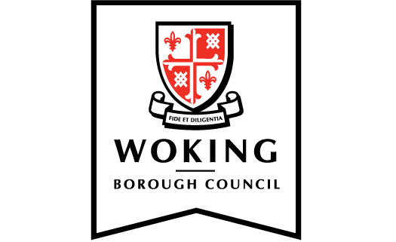

Climate Change Working Group meeting notes
  - Held on 25 November 2020

1. Climate Emergency Action Plan update
An update on the Climate Emergency Action Plan (CEAP) was presented to the group along with a document summarising further progress against the priority actions identified for 2020/21.

Work has commenced on preparing a renewable energy strategy. Assessments to inform renewed Display Energy Certificates (DECs) for the Civic Offices and Monument Way were undertaken mid November 2020. The reports will be published when available on the Council’s website.

On 17 November 2020, the Government announced a Ten Point Plan to push the United Kingdom towards a net-zero emissions by 2050. This will see £12bn investment and the creation of new green jobs. A UK Energy Strategy is also expected before the end of 2020.

Planet Woking held its first virtual event on the 20 October 2020 with 49 residents joining an online webinar to find out how making changes to everyday activities at home could make a positive contribution towards a sustainable Borough. The next virtual event is scheduled to be held on 2 February 2021 on the theme ‘The Great Outdoors’. Further details are available online at www.planetwoking.co.uk/events.

RESOLVE that

(i) the status report be noted.

3. Woking Environment Action Climate Action Group update
A report on the Climate Action Group (CAG) was introduced. CAG is a sub-group of Woking Environment Action with the aim of supporting Woking Borough Council to achieve its net zero ambition. The report included activities identified in supporting small business and local residents towards reducing carbon emissions.

The following recommendations were presented to the Working Group:

CCWG to support the development of CAG’s Carbon Tracker Tool and be willing to work together to promote the tool to local businesses, with a view to potentially establishing a ‘Planet Woking’ awards scheme in the future.

CCWG to support the development of a Planet Woking Innovation Competition, which would be co-sponsored by WeAct and Planet Woking.

CCWG to consider whether there are any projects/ideas that it would like WeAct to provide grassroots support for, as part of Surrey County Council’s Your Fund Surrey initiative.

Read more about the Your Fund Surrey initiative.

CCWG members to help promote We Act’s updated website and social media channels.

CCWG to obtain a report updating on the Council’s progress against the Ashden 31 Climate Actions at its next meeting.

The Working Group supported the recommendations. With regards the last recommendation, a view will be taken as to when the Ashden update report can be completed bearing in mind current officer capacity.

Members welcomed the recommendations and agreed to:

RESOVLE that

(i) The Climate Action Group update be supported.

4. Action Surrey update
An update was given on Action Surrey activities for the period 1 July 2020 to 30 September 2020. It was noted that the Action Surrey partnership of local authorities had successfully been awarded £6.2 million in funding under the government’s Green Homes Grant Local Authority Delivery scheme to upgrade the energy efficiency of properties in Surrey. The project has been named Green Jump Surrey.

Details of household qualifying criteria for the fund were outlined as well as actions taken by Action Surrey in readiness to deliver the scheme.

Read more information about Green Jump Surrey.

In addition to the government’s grant, Surrey County Council is contributing £750,000 to the Green Jump Surrey project as top-up funding to cover the cost of installing measures where the cost exceeds £10,000. This will be particularly relevant for the installation of solid wall insulation, air source heat pumps and solar thermal. With Surrey County Council’s contribution, the cost of works up to £15,000 would be covered for eligible households.

It was noted that so far the scheme has attracted 150 eligible households, of which 10 are based in Woking Borough.

5. ThamesWey update
A ThamesWey report was presented covering initiatives currently being progressed by its Environmental Projects team, including the Green Jump Surrey project.

Works are continuing to progress on the new Poole Road low carbon energy centre. View a time-lapse video of the construction works showing the progress of the project.

6. Minutes
The minutes of the meeting of the Climate Change Working Group held on 24 September 2020 were agreed as a true and correct record.

