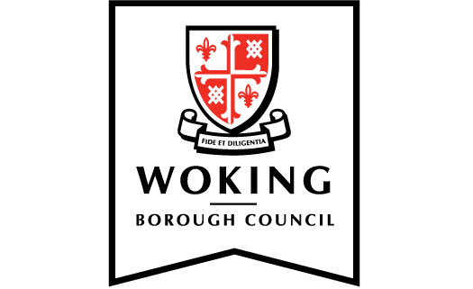

Members’ code of conduct:

Protocol for members’ access to confidential information of council-owned companies

1. Introduction

  - The council has adopted a members’ code of conduct that sets out the standards of behaviour expected of members.

  - The council has also adopted ‘Arrangements for dealing with standards allegations under the Localism Act 2011’ (‘Arrangements’).

  - This protocol applies to members’ access to the confidential information of council-owned companies. Such information includes, but is not limited to, confidential board papers and confidential information imparted at board meetings.

2. Confidential Information of council-owned companies

2.1 The members’ code of conduct imposes obligations on members in respect of confidential information. In particular, paragraph 4.1 of the members’ code of conduct provides:

4. Confidentiality and access to information
As a councillor:
4.1 I do not disclose information:
a. given to me in confidence by anyone
b. acquired by me which I believe, or ought reasonably to be aware, is of a confidential nature, unless
i. I have received the consent of a person authorised to give it;
ii. I am required by law to do so;
iii. the disclosure is made to a third party for the purpose of obtaining professional legal advice provided that the third party agrees not to disclose the information to any other person; or
iv. the disclosure is:
1. reasonable and in the public interest; and
2. made in good faith and in compliance with the reasonable requirements of the local authority; and
3. I have consulted the Monitoring Officer prior to its release.

2.2 The provisions of paragraph 4.1 of the members’ code of conduct shall apply to confidential information of Council-owned companies (note: ‘Council-owned company’ shall be substituted for ‘Council’ in paragraph 4.1b.iv.2).

3. Breach of protocol

3.1 On 8 April 2021, Council resolved that compliance with Standards Protocols shall be deemed to be a requirement of the Local Government Association’s Model Members’ Code of Conduct.

3.2 Failure to comply with this protocol could constitute a breach of the members’ code of conduct.

Adopted by the council on 30 July 2020

Amended May 2021 (reference made to the Local Government Association’s Model Members’ Code of Conduct)

