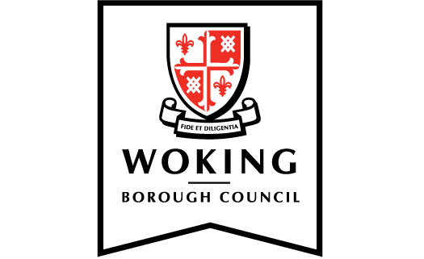

Members’ code of conduct:

Protocol for complaints submitted by members

1. Introduction

1.1 The council has adopted a members’ code of conduct that sets out the standards of behaviour expected of members.

1.2 The council has also adopted ‘Arrangements for dealing with standards allegations under the Localism Act 2011’ (‘Arrangements’).

1.3 This protocol applies to complaints submitted, under the members’ code of conduct, by a member against another member.

2. Confidentiality

2.1 Member complaints against another member shall be confidential to:

(i) the two members concerned (i.e. the member submitting the complaint and the member who is the subject of the complaint);
(ii) the Monitoring Officer, and
(iii) the persons notified of the complaint by the Monitoring Officer in accordance with the arrangements.

3. Breach of protocol

3.1 On 8 April 2021, Council resolved that compliance with standards protocols shall be deemed to be a requirement of the Local Government Association’s Model Members’ Code of Conduct.

3.2 Failure to comply with this protocol could constitute a breach of the members’ code of conduct.

Adopted by the council on 4 April 2019

Amended May 2021 (reference made to the Local Government Association’s Model Members’ Code of Conduct)

