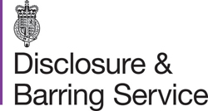
The DBS Update Tracker Service  www.gov.uk/dbs | Civic Offices  Gloucester Square  Woking  Surrey GU21 6YL  Telephone (01483) 755855  Facsimile (01483) 768746  DX 2931 WOKING  Email wokbc@woking.gov.uk  Website www.woking.gov.uk

In line with the Disclosure and Barring Service Update Serice, I hereby confirm that I give Woking Borough Council the authority to receive update information (within the meaning of section 116A of the Police Act 1997) in relation to my criminal record Certificate for the purposes of asking an exempted question within the meaning of section 113A of the Police Act 1997; or in relation to my enhanced criminal record Certificate for the purposes of asking an exempted question for a prescribed purpose within the meaning of section 113B of the Police Act 1997.

Print Name: …………………………………………………………………………………………

Signed: ……………………………………………………..Dated: ……………………………….

Date of Birth: ……………………………………………..

